1. **Agenda**:
   1. Read-Only Volume
2. By default, Volumes are **read-write** so a container can write there.
3. In case, of **Bind Mount**, the idea is that we should be able to change inside the container from outside (from the code base on host machine). But we know that volumes are by default Read-Write which means container also able to make changes on the host path (bind mount). We should be able to make changes in the code base and those changes should reflect into mapped path inside the container but not vice-versa.
4.   
   “C:\jatin\Practice\Docker\data-volumes-03-adj-node-code\data-volumes-03-adj-node-code:/app**:ro**”   
   Basically, this **ro** (read-only) will make the /app folder inside the container read-only. So, the mapped path on Host Machine will also become read-only for the container.   
   Now docker/container will not be able to write into this folder (“C:\jatin\Practice\Docker\data-volumes-03-adj-node-code\data-volumes-03-adj-node-code”) or sub-folder.
5. But we can notice that /app/temp and /app/feedback folders must be writable as app needs to store files there.   
   **Solution**: Define volume for those paths as longer path wins in read-write concept too (as long path wins in bind mount).  
   NOTE: We have already -v feedback:**/app/feedback** so this is longer path than “C:\jatin\Practice\Docker\data-volumes-03-adj-node-code\data-volumes-03-adj-node-code:**/app:ro**” So, this longer path will win and it(**/app/feedback**) is writable as we didn’t apply **:ro**.  
   Define anonymous for /app/temp to make this writable:  
   -v /app/temp  
   Why anonymous?  
   As we don’t want it to survive container restart.  
   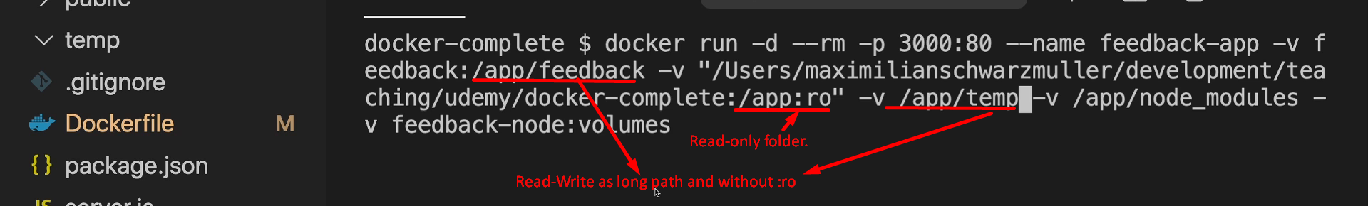
6. **NOTE**: During Bind Mount, adding :ro (read-only) will make the mapped folder inside the container read-only not the host machine folder, which is being mounted into the container but eventually, the host machine will become effectively read-only as container folder is read-only. Try to understand 😊  
   **NOTE**: If you add :ro during bind mount, you may get exception related to **node_modules**.   
   **Solution**: Create empty node_modules in codebase.   
   **Jatin NOTE**: The above -v /app/temp will not work and you will face this issue  
   